**PLUTO & OBS SETUP FOR DVB-S2 TRANSMISSIONS TO VK3RTV**

Version 15042025 (mostly collated by Rob VK3IE)

For this project you will need a Pluto and OBS (latest version)

Beware the Clone Pluto’s from ALI have been known to have issues.

**You may need Adalm Pluto Windows, Linux or Apple Drivers**

[**https://wiki.analog.com/university/tools/pluto/drivers/windows?rev=1649240552**](https://wiki.analog.com/university/tools/pluto/drivers/windows?rev=1649240552)

**<https://github.com/analogdevicesinc/plutosdr-m2k-drivers-win/releases/tag/v0.9>**

*Pluto appears works best via USB on a USB 2 Port.* If using a Network adapter you milage can vary, some users say they have found too much packet loss etc, and usb is better others say its as good as USB. The Pluto does NOT appear to like long USB cables. The standard 0.5m ones work but any longer than a metre or so and the USB connection works (you can read the menu on the pluto) but is unreliable (streaming breaks up, gets choppy etc) and gets worse as the length is increased.

***Ethernet usage***

The ethernet adapter below from Amazon appear to work according to some users (but not all).

<https://www.amazon.com.au/dp/B086WCG4SR?ref=ppx_yo2ov_dt_b_fed_asin_title>

If you are going to use an Ethernet adapter there are a couple of things to do or it wont work reliably. Look in the root directory of the Pluto, this can only be done via USB. There is a file in the root directory of the pluto called settings.txt, this file must be modified to the settings as follows.

[NETWORK]

hostname = pluto

ipaddr = 192.168.2.1

ipaddr_host = 192.168.2.10

netmask = 255.255.255.0

[USB_ETHERNET]

ipaddr_eth = xxx.xxx.xxx.xxx <- The IP address that you want the Pluto to use on your network

netmask_eth = 255.255.255.0 <- Leave as 255.255.255.0

gateway_eth = xxx.xxx.xxx.xxx <- The IP address of the gateway or router on your network

Save the config.txt file back to the pluto. The next step is important or the pluto wont read the config.txt file and use its settings.

***\*Now the important bit\****

Right Hand Lower Corner of PC, Eject Pluto SDR, don’t unplug it

DO not physically remove the drive just click eject

Blue LED will change to a slow flashing Blue LED when done

May take a few seconds, just wait and don’t unplug Pluto from PC until done.

Now unplug the USB and plug in the ethernet adapter. The pluto needs to be powered via the adapter or a power supply plugged into the Pluto.

You can ow use the IP address you plugged into the config.txt file to access your pluto via a web browser. The same IP address must be used in the streaming string as well. Make sure the IP address you are using is not used by anything else on your network and is reserved for the pluto’s use at the router.

***Firmware for Pluto+*** <https://g1lps.com/f5oeo-pluto-firmware/>

Update FW for normal Pluto: Copy and paste the URL below into a web browser

<https://mega.nz/file/E052FRhK#fwwBkwbKOObyhd91E9xZUIX2h9sBUM8FaMPsBVKniQs> Version Date 03032021 (this works well)

<https://mega.nz/file/ps5WXZZS#3V2XtPA-a5e1W42Uc9hstvvIDYiTataOD5ATgKbreLw> Version Date 14042025

<https://g1lps.com/f5oeo-pluto-firmware/> Firmware for the PLUTO +

It should take you to a file storage page that has the firmware required. The downloaded file is a ZIP file that contains a file called pluto.frm

Plug you PLUTO into your PC (preferably a USB2 port) where it should detect as a drive.

it should detect as a drive. No detection most likely a charging cable, 2 wires

Ensure you have a proper OTG or 4 wire cable, many cables USB-A to MICRO-USB can be charging cables and only have 2 wires.

A good quality USB-A to Micro-USB will ensure good data Flow from PC to Pluto

* Unzip and copy the above file **pluto.frm** to the Pluto main or root dir.

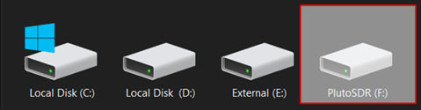

Once copied to Pluto:

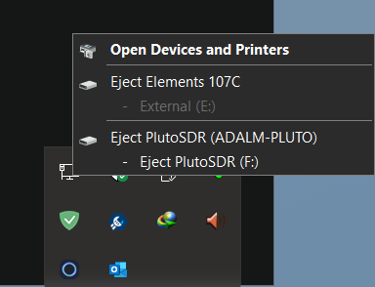

* Right Hand Lower Corner of PC, Eject Pluto SDR, don’t unplug it
* DO not physically remove the drive just click eject

This will reboot Pluto and the Blue LED will flash fast

Blue LED will change to a slow flashing Blue LED when done

May take a minute or just wait and don’t unplug Pluto from PC.

Once done:

* In a web browser type 192.168.2.1 or the IP address you set if using ethernet
* Or go to the PLUTO drive in your favourite file explorer, double click on info.html (will not work via ethernet)

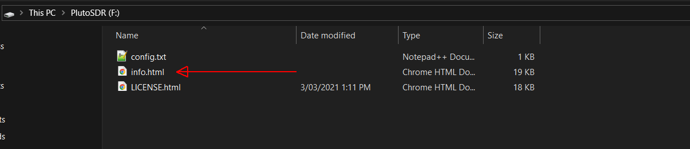

**Pluto will pop up with a screen similar to below.**

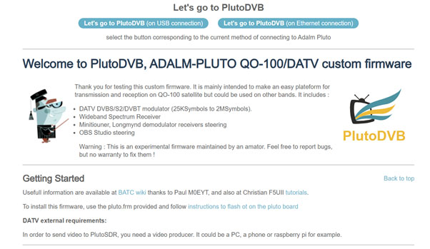

**Once here we need to setup Pluto**.



* Click on “Let’s go to PLUTODVB on USB connection” if using USB
* If you click on “Let’s go to PLUTODVB on ethernet connection” your browser may come up with an error. Change the URL showing on your browser from **http://setup.php** to **http://xxx.xxx.xxx.xxx/setup.php** (where xxx.xxx.xxx.xxx is the IP address of the Pluto).

I have not had an issue at 4000KSB (no dropped frames or packet loss) but If you have are using a USB to Ethernet device you may have issues. It has been noted that some QO-100 users have packet loss, using usb to ethernet and they are only doing low 333KSB rate, I would guess as we are pushing the Pluto it may be worse, again your mileage may differ. Or whatever works best for you, suck it and see they say.

If your Pluto does not enter into settings after clicking Let’s go to PlutoDVB, you may need in install Adalm Pluto Drivers.

Adalm Pluto Windows, Linux or Apple Drivers

<https://wiki.analog.com/university/tools/pluto/drivers/windows?rev=1649240552>

https://github.com/analogdevicesinc/plutosdr-m2k-drivers-win/releases/tag/v0.9

After driver installation:

* In a web browser type 192.168.2.1 or xxx.xxx.xxx.xxx (which is the IP address of the Pluto)
* Or go to the PLUTO drive in your favourite file explorer, double click on info.html (cant do this on ethernet)

Screen below under the System tab

* Check DATV
* Check RTMP
* Apply Settings
* Your callsign (UPPER CASE) in the locations “CALLSIGN” and “DVB Provider Name”.

Always APPLY settings after each section.

There are many other settings to see as you scroll down page, at this stage they are not required if using USB. Add your USB to Network dongle if using one.

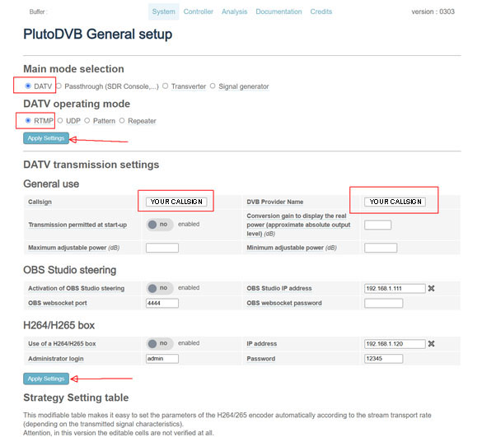

**Once Done: Scroll back to the top of the screen click on Controller**

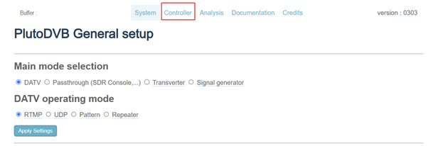

**Should see screen below:**

The settings below are for VK3RTV the VK3 ATV repeater.

* Set Freq-Channel to Custom, located all the way down in small windowed area.
* Set Frequency to your desired frequency in MHz
* Set Mode to DVB-S2
* Set SR (K Symbols) to custom to 4000
* Set Mod to QPSK
* Set FEC to 2/3
* All other settings as indicated

Don’t forget: **Apply settings**, other settings in Pluto do not really affect the over-all output It’s all done in OBS. You’re settings are sending the stream from OBS to Pluto.

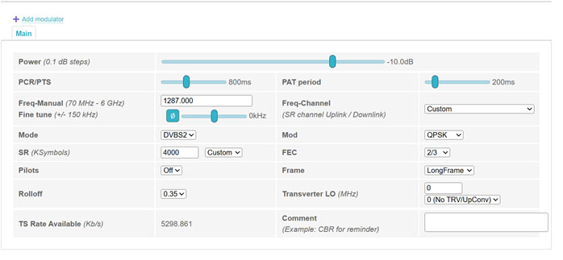

**All being well that’s the Pluto Done sort of Done.**

**OBS Settings:**

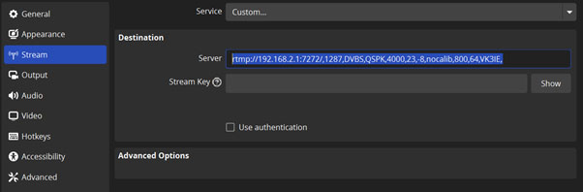

In Stream add the following line in server, as written don’t miss any commas “,”

* rtmp://192.168.2.1:7272/,1287,DVBS2,QSPK,4000,23,-8,nocalib,800,64,Callsign,

What this all means:

rtmp://192.168.2.1:7272/ IP address of your Pluto and port. If you are using USB then the address is more than likely 192.168.2.1, if you are using a USB to Ethernet adapter you will have to find the IP address that has been assigned by your network for the adapter to plug in here.

,1287 Frequency in MHz

,DVBS2 Mode

,QSPK Modulation

,4000 Symbol Rate (SR) (K Symbols per Second)

,23 FEC (23=2/3 34=3/4 etc)

,-8 Power output from PLUTO, 0 (Zero) is full power

,nocalib (part of PLUTO calibration if changed can send a spike on TX that may let the smoke out of a preamp)

,800 Delay to allow PLUTO to get its act together on streaming (600 default)

,64 Audio Symbol rate

,Callsign, Your Callsign (Upper Case - same as you put into the PLUTO)

Currently I don’t know of a method of setting the PIDS (Video PID, Audio PID, PCR PID etc)

For bench testing/proof of concept, suggest plug and small antenna into the Pluto set power in the Server setting stream to 0 (zero) currently -8, you should be able to receive on a local receiver Before going Big Guns into your system. Don’t forget to put the power back to -8 to -10 pending on your drive setup etc or you may let the smoke out of the AMP.

**Under Output in OBS:**

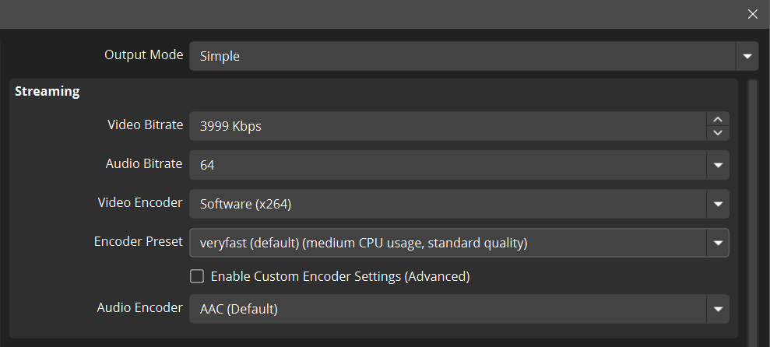

Video Bitrate 3500 to 4500 is about the best pending on your PC gruntness or the amount of movement or action, a still image would require less were lots of movement will require more, your milage will vary, Audio Bitrate, 64 or 128 again depends on the quality of file you are playing, In a nutshell, depending on how the Video you are showing was created is related to how good the output and reflect on settings. Fiddle and watch find a happy medium and be happy with that.

Audio settings set sample to 44.1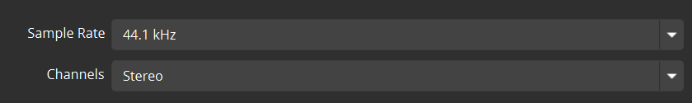

* Under Video set to 1920 x 1080 both
* FPS to 25 PAL or 50 PAL

VK3RTV responds better to 25 or 50 FPS

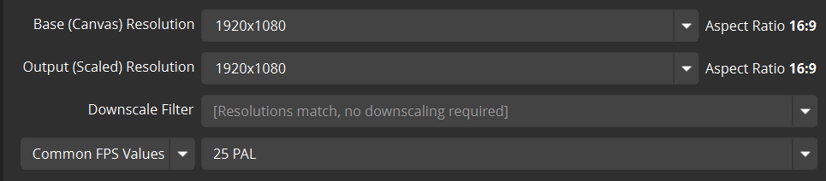

**Click the Start Streaming in OBS**

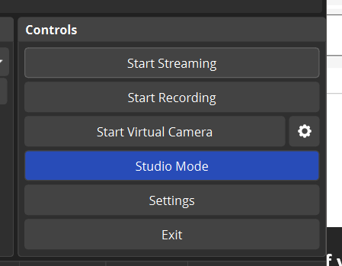

It should pretty much be an instant start; you will see output happening in OBS lower task bar. VK3BVR discovered, older versions of OBS “may” not connect to stream server.

Update to the latest and use 31.03 resolved that issue.

There is a fix to run two versions of OBS at that end of this document if required.

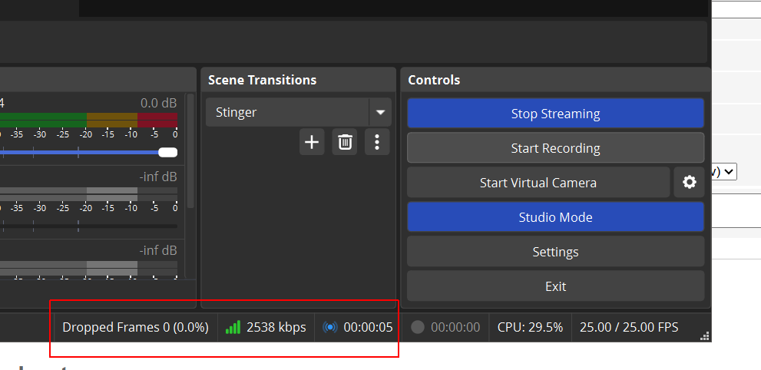

Pluto will take a few seconds to start/kick in, there is no indication on Pluto that it’s happening. If it does not start instantly or hangs, there is a problem with stream sever (OBS), settings etc. Check that Stream server settings in OBS are correct, no extra spaces, all comments server line have comma “,” after each entry, as seen, spelling in same case.

On the Lower R/H side of OBS you will see the kbps this will alter, pending on your stream it more of an indication.

When Stream starts in OBS, Pluto will start automatically, when its ready, control screen will go to Switch OFF, you may get a red square indication its Txing as well, one PC I have does not do the Red Square thing.

* There is no indication of what is happening as far as what the TX is doing after you hit START STREAMING. It takes about 5 seconds for the Pluto to output a signal (be patient) and then about 3 seconds for a picture to appear. The same periods apply to what happens after you hit STOP STREAMING.

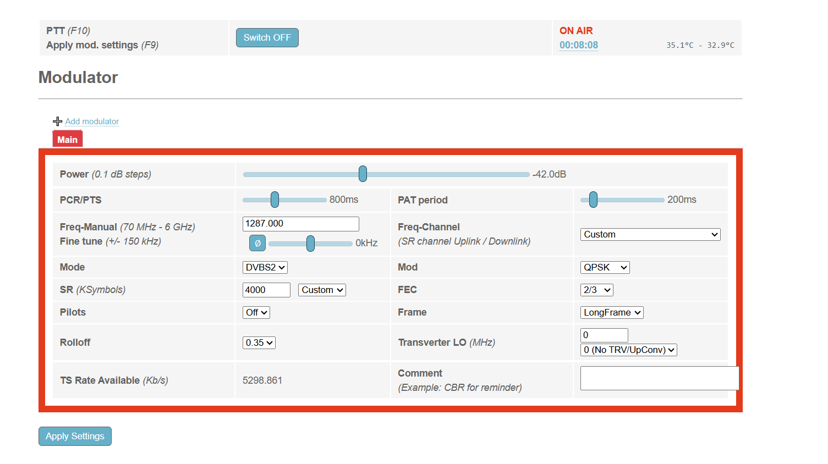

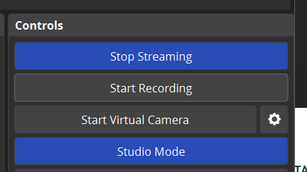

Click on Stop Streaming in OBS to Stop all Txing from Pluto

While streaming you can click on Analysis to see the data leaving Pluto live.

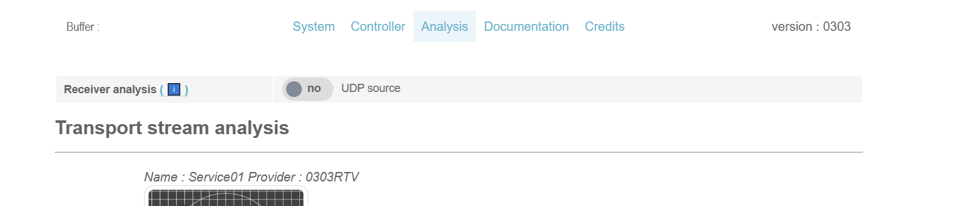

**This is where you can tell or see if it’s going to be OK or Not.**

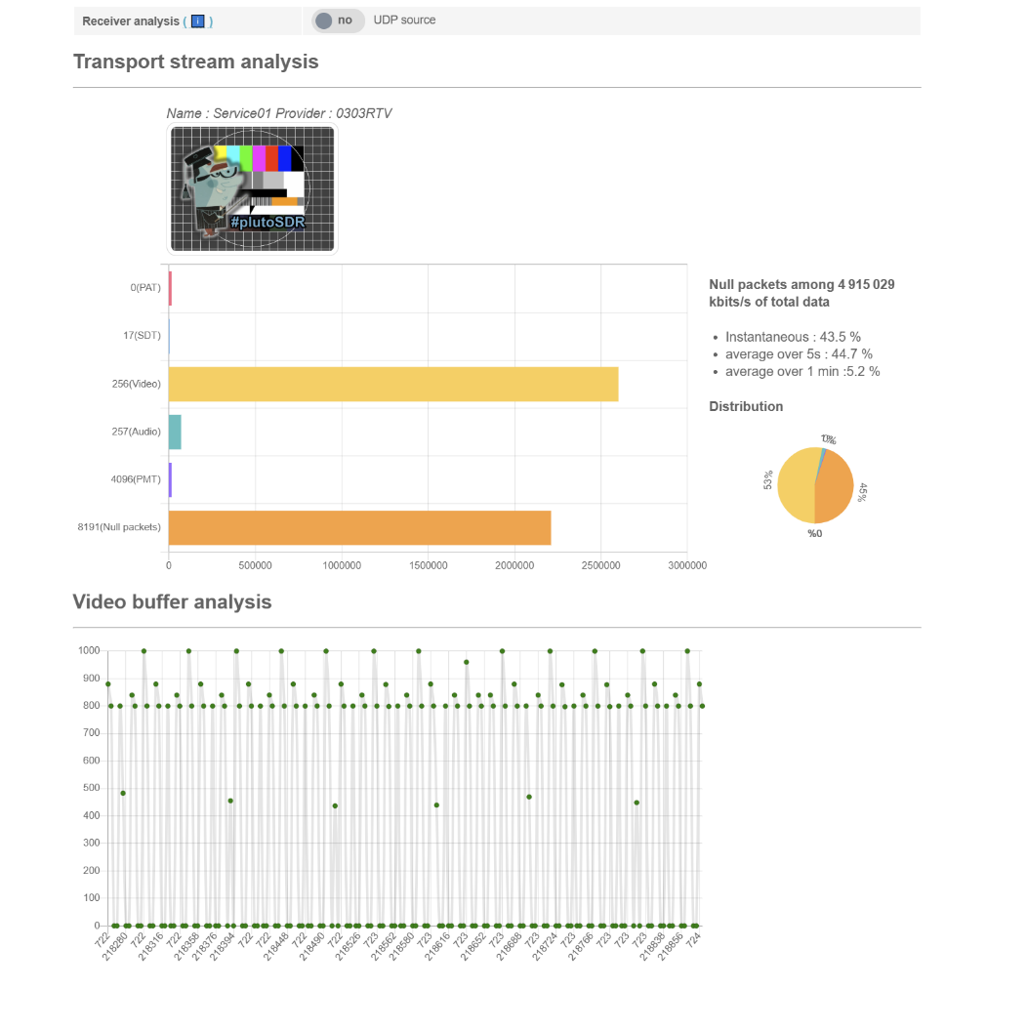

Need to get the Null packets Low 10 to 25% they say is OK for qo-100,

More Yellow less Orange in the Pie

I guess the same would apply to what we are doing on RTV,

More on this, I have found Increasing Video Bitrate in OBS can improve this, again pending on the PC gruntness, it’s all relative to the video, how it was created, as in Bit rates, FPS etc. As mentioned, find a happy medium and be happy with that.

Ignoring the constellation as a bit of wire was used to RX in the sample below.

Depending on the how much grunt your PC may have in this situation increased bit rate will improved the over all reception locally using a minituner, Null Packets down to 13% and the little man in has a smile on his face so that has to be good. This transmission was done with Video Bit rate in OBS set to 4500, but again pending on your OBS and PC etc less is more or more is good.

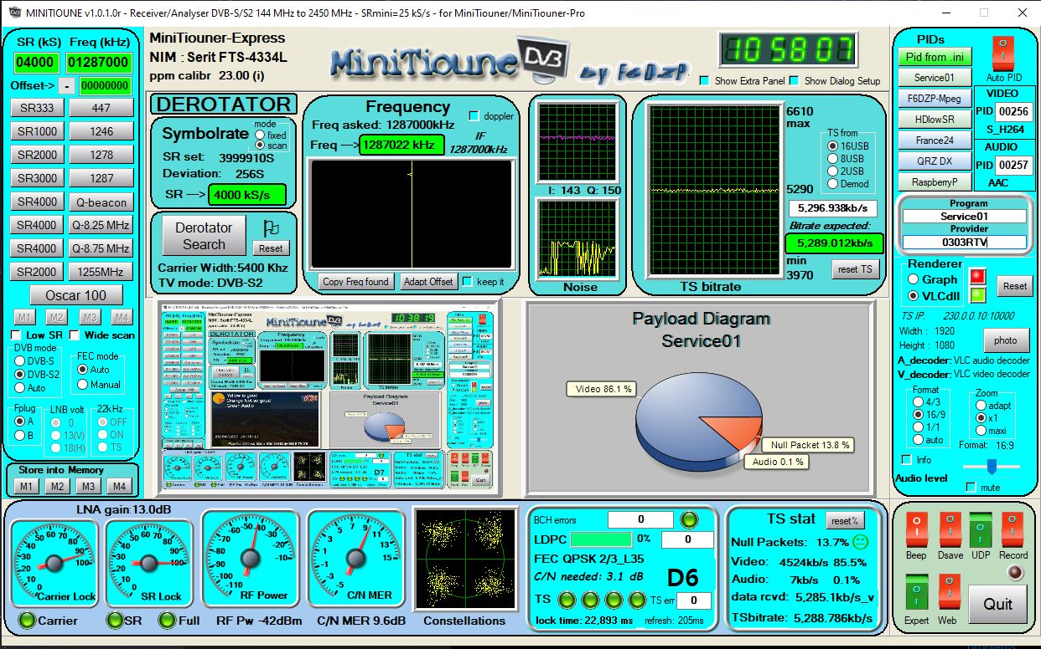

Null Packets:

When you set the SR and Fec and modulation there is a TS bitrate that correspond.

If your video data + audio data + DVB tables are lower than this bitrate, the multiplexer is supposed to add null packets to give the TS bitrate needed.

If, for some reason, your multiplexer doesn't give the good TS bitrate but a lower bitrate, then, if you are using the F5OEO Pluto firmware, it adds itself Fake Null Packet to be sure that your modulator will have the good TS bitrate.

Normally you should have only Null Packets. I have added the detection of Fake Null packets in Minitioune to let people know what is happening to their final TS data.

If you have only Fake null Packets that shows that you have 2 problems:

1) no Null packets => you give too much bitrate to video + audio data so no place for Null packets. That will produce some problem with encoding datarate variations that always exist even you are in CBR mode

2) there are Fake null Packets => that indicate that you have set the TS datarate of the multiplexer too low, so it is the Pluto firmware that must add Fake Null packets to be sure that the final TS bitrate will be good.

Jean-Pierre F6DZP

I found setting up Zowiebox and using, was must nicer than using the LINKPI unit,

Using the Pluto FW 0303.

**How to set up a second or New OBS/ portable OBS if needed, not clash with an earlier version you may already have installed on your system.**

**You can have two or more separate installations**

* **Download latest OBS from the website from the Download page.**

[**https://obsproject.com/download**](https://obsproject.com/download)

* **UNZIP the installer.exe somewhere, Desktop is easy to find**

**7zip will unzip .exe** [**https://www.7-zip.org/**](https://www.7-zip.org/)

**You will end up with a DIR/Folder as below**

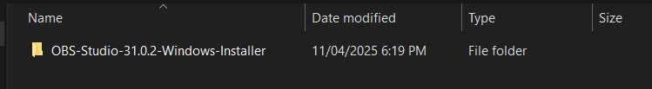

* Click to enter Dir OBS-Studio-31.0.2-Windows-Installer you have UNZIPPED
* Create a .txt file called portable_mode.txt

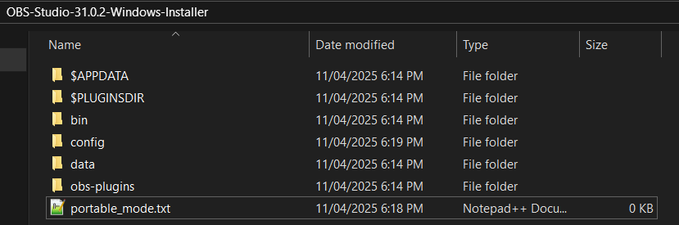

* **click to enter Dir bin,**
* **click to enter Dir 64bit**
* **Then Run file obs64.exe**

**This will run a complete separate and new install of OBS and will not interfere with other installs they say, but your milage may differ.**

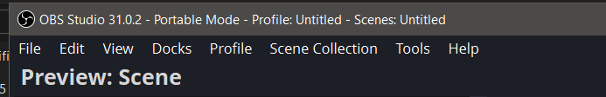

I found setting up Zowiebox and using, was must nicer than using the LINKPI unit,

**Vmix users: (Work In Progress)**

Settings much the same just use info supplied to use OBS and **not** what is inserted below.

You can put your ,Callsign, as shown below in Stream Name or Key.

In URL put in rtmp://192.168.2.1:7272/,1287,DVBS2,QSPK,4000,23,-8,nocalib,800,64,Callsign, as described for OBS above.

The rest you can fiddle. Please advise what works best to pass on to others.

